Pseudo N95 3D Printed Masks – Steps for finishing:

After printing you should have three parts.

1. The body
2. The hatch
3. The nose cap

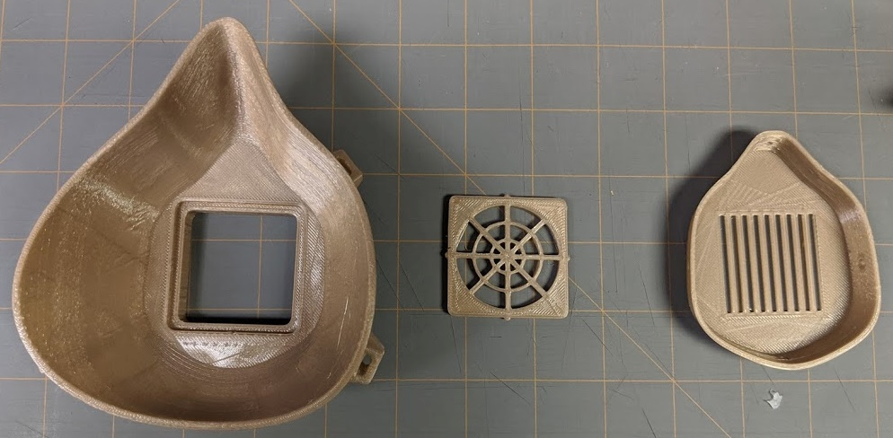

Figure 1: 3D printed parts from left to right (1) Body, (2) Hatch, and (3) Nose Cap

Step 1: Cut weather stripping to length

We are using Frost King D-profile 5/16 x 1/4 inch Self-Stick Weatherseal.

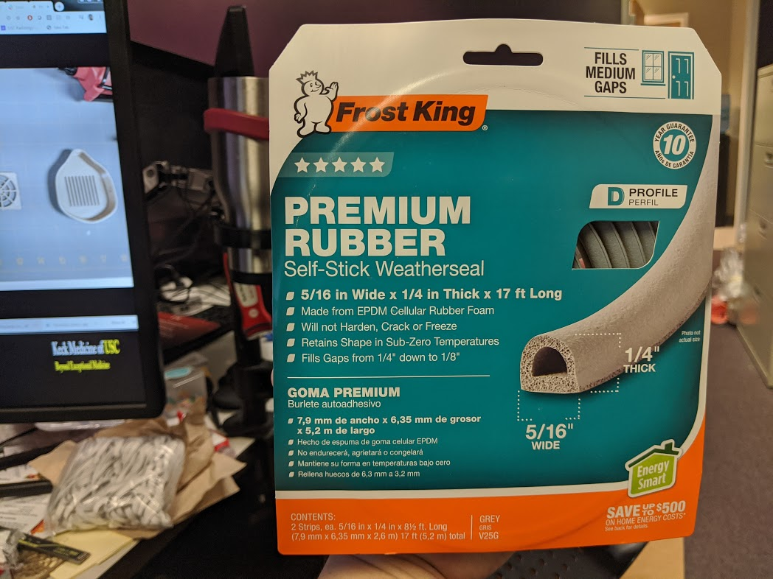

Cut weatherseal to the following dimensions:

* Medium masks: 14.5 inches
* Large masks (Version 0): 15.0 inches
* Large masks(Version 2L): 15.5 inches

We are using DAP Weldwood Contact Cement

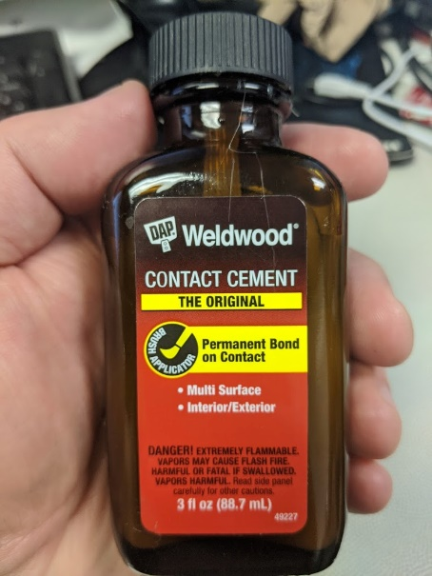

Use contact cement on the ends of the weatherseal. Let sit for 5-10 minutes. Touch both ends to form a loop.

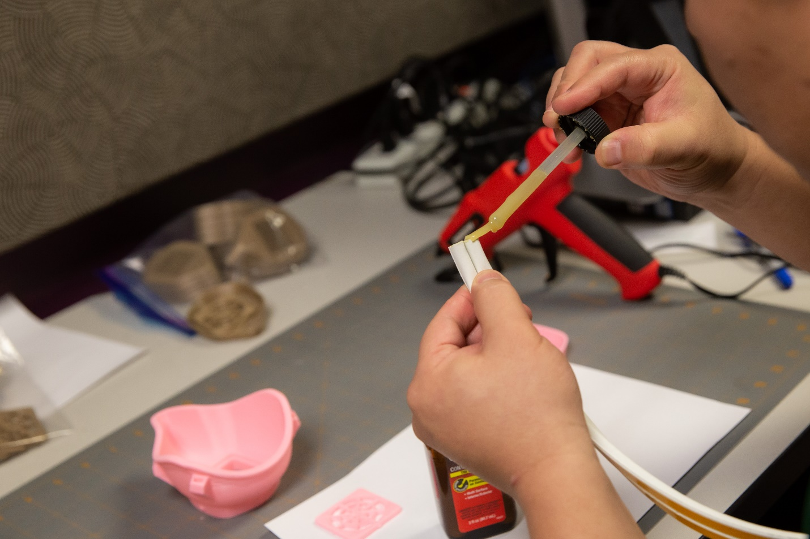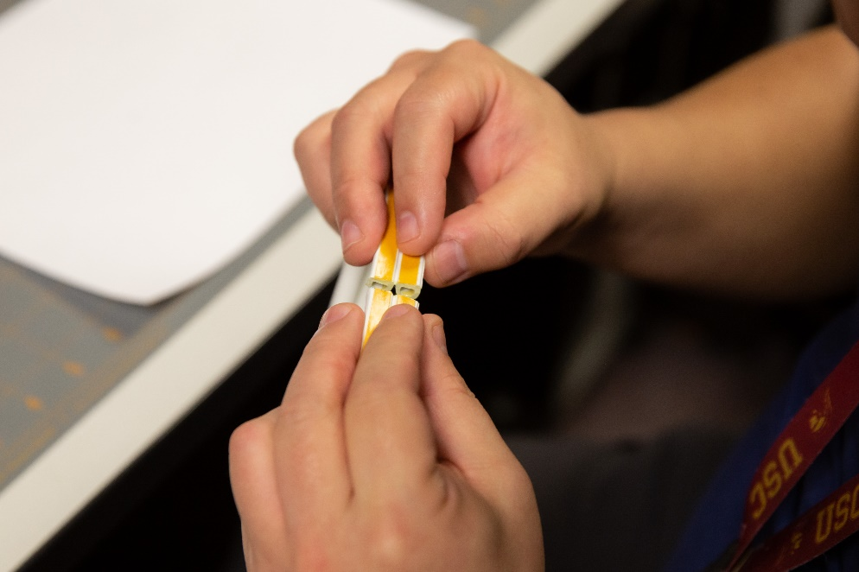

When dry, separate weather stripping into two loops

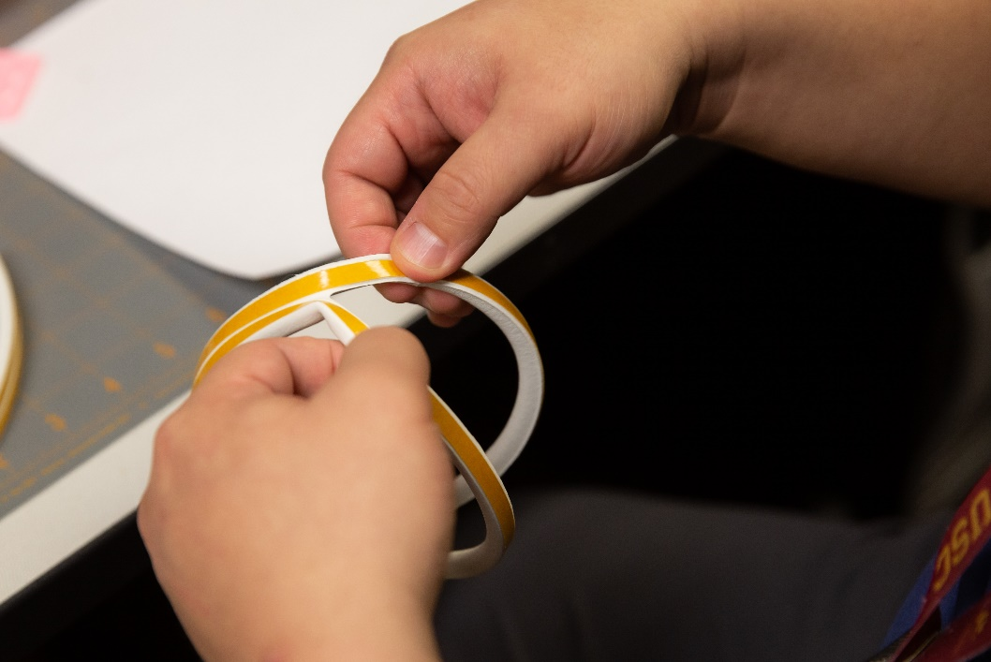

Peal the backing off the adhesive to start applying to the Mask Body.

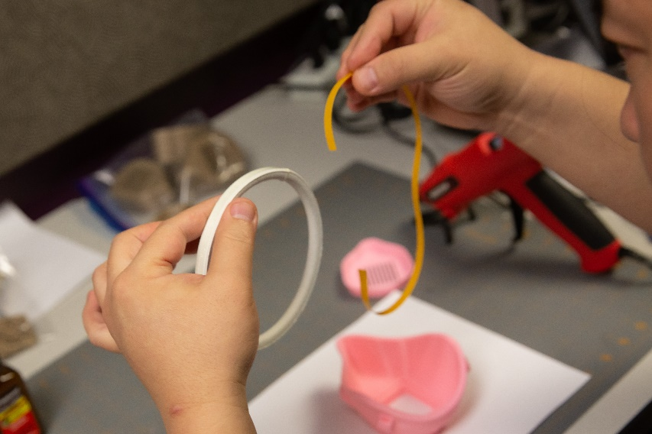

Start by putting the contact cemented end to the bottom of the Body.

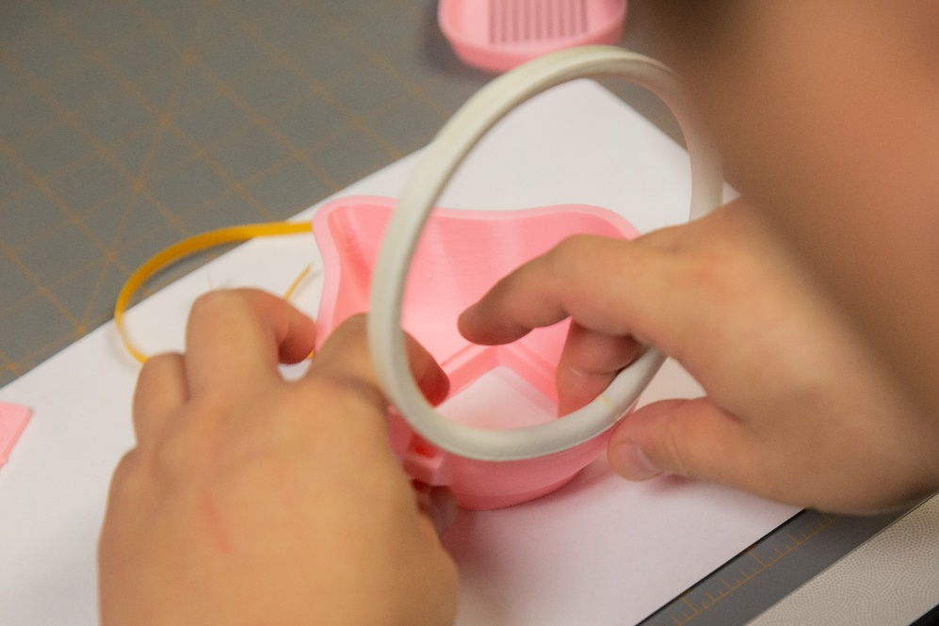

Work around the parameter touching down the adhesive to the ledge. Try to make a slight overhand on the inner part of the mask and a larger overhang on the outer portion of the mask.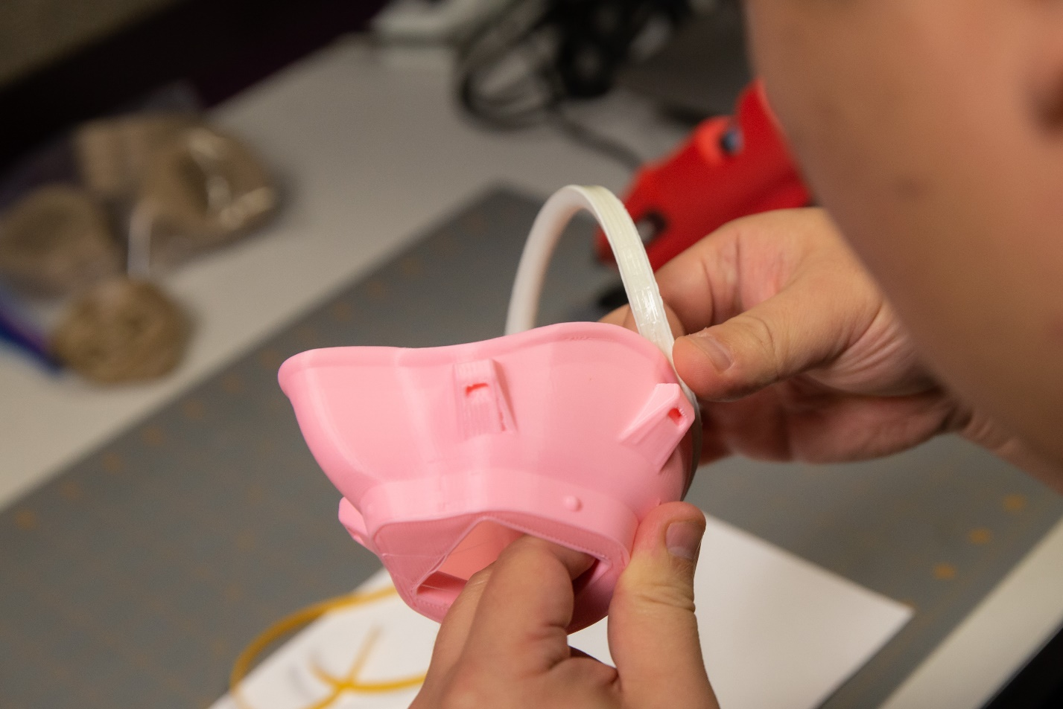

Pay close attention to the bridge of the nose interface for tight seal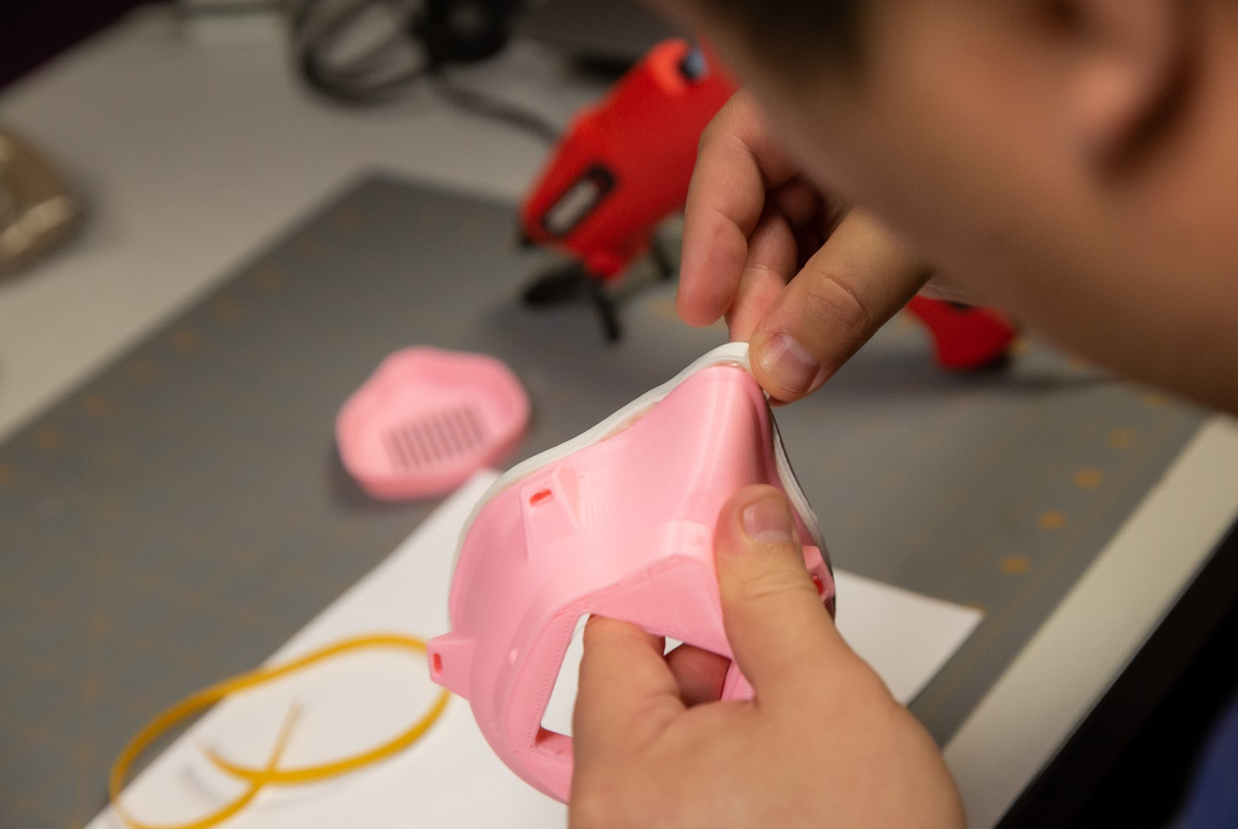

Begin hot gluing. The recommended technique is two part. First lay a thick bead of hot glue at the seam between the mask body and weather stripping.

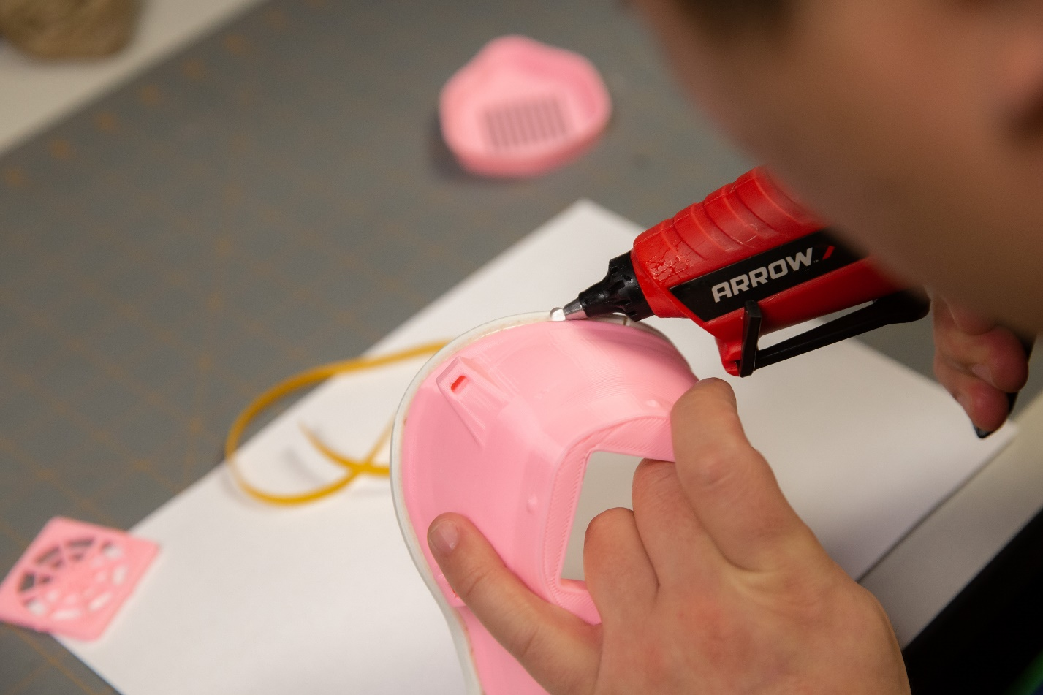

Then take the tip of the glue gun to evenly spread the glue into a wide swath forming an airtight seal between the mask and the weather stripping.

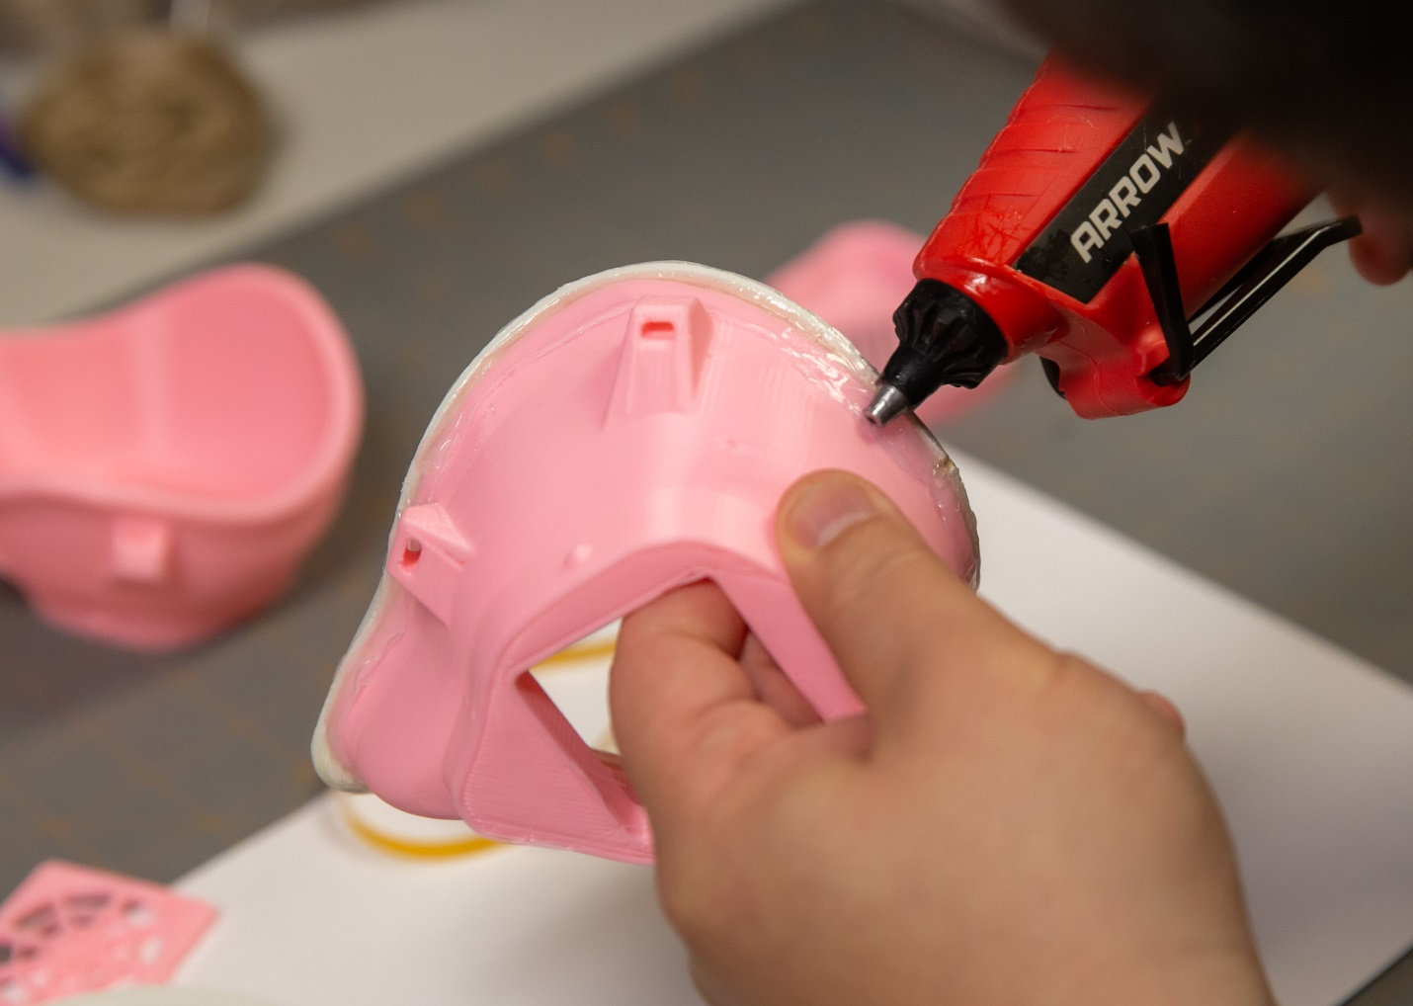

For filtering material we are using Honeywell HEPAClean Air Purifier Filter model HRF201B

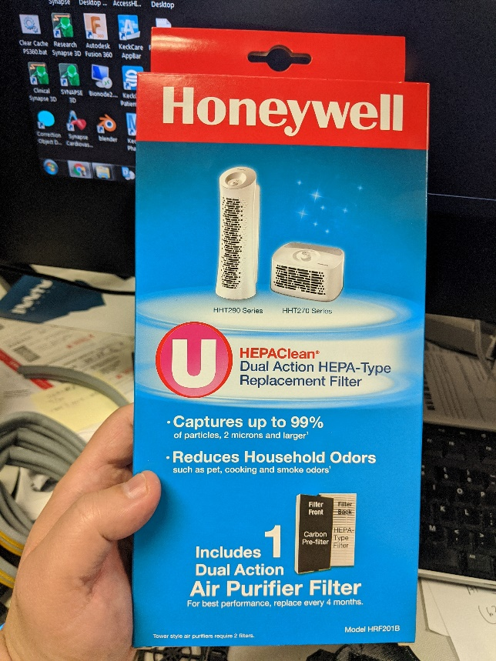

Remove the black Carbon Pre-Filter from the front of the filter. Gently break open the top edge of the filter. Gently detach the sides of the HEPA filter. Keep central filter intact.

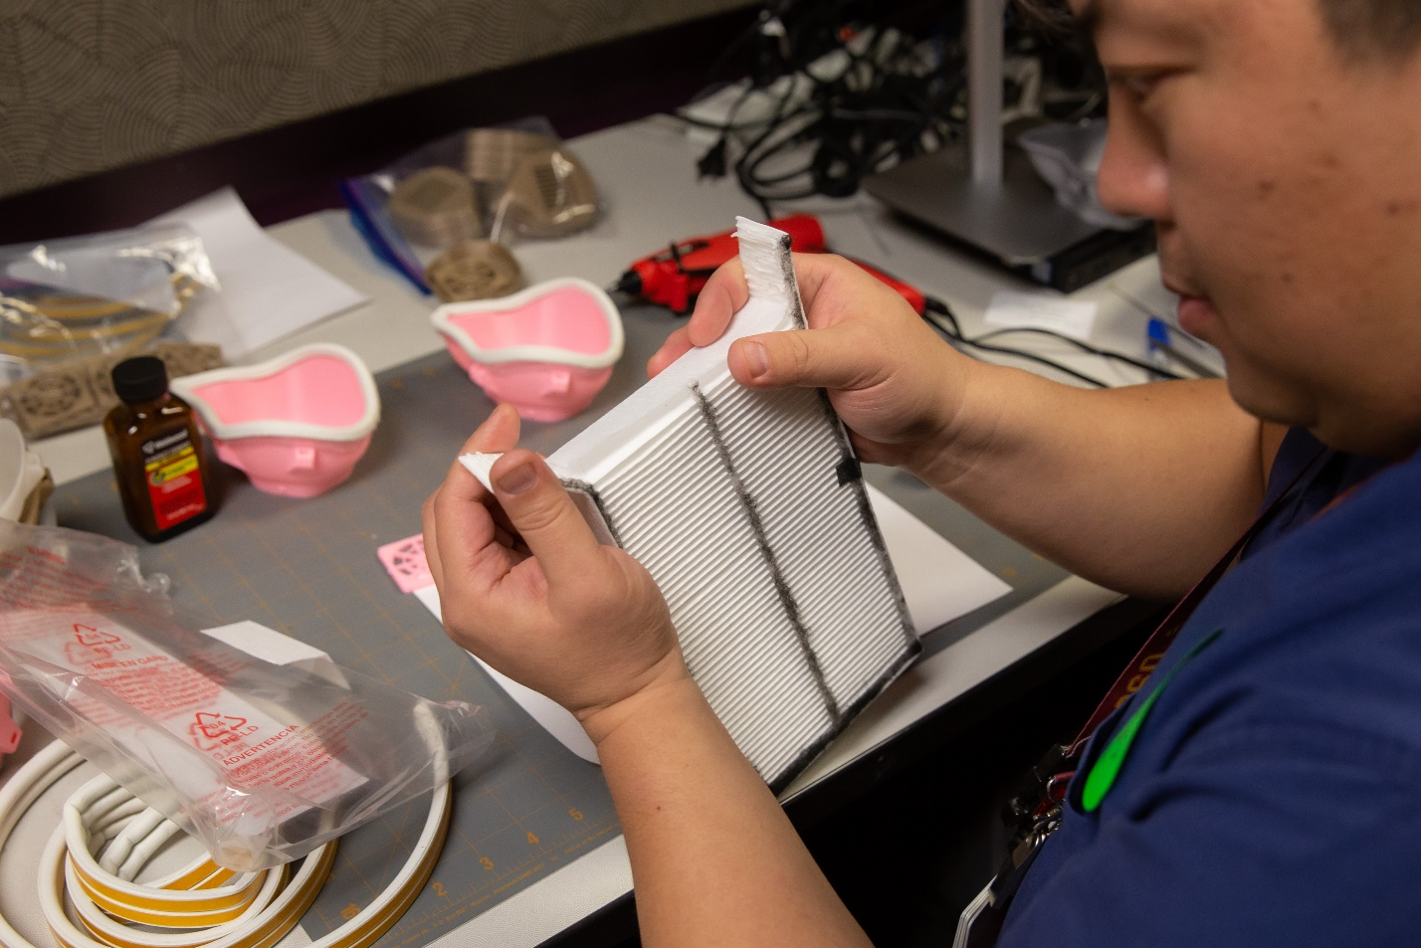

Cut the HEPA filter into 1 fold sections. The end piece should have a fold in the middle of the filter.

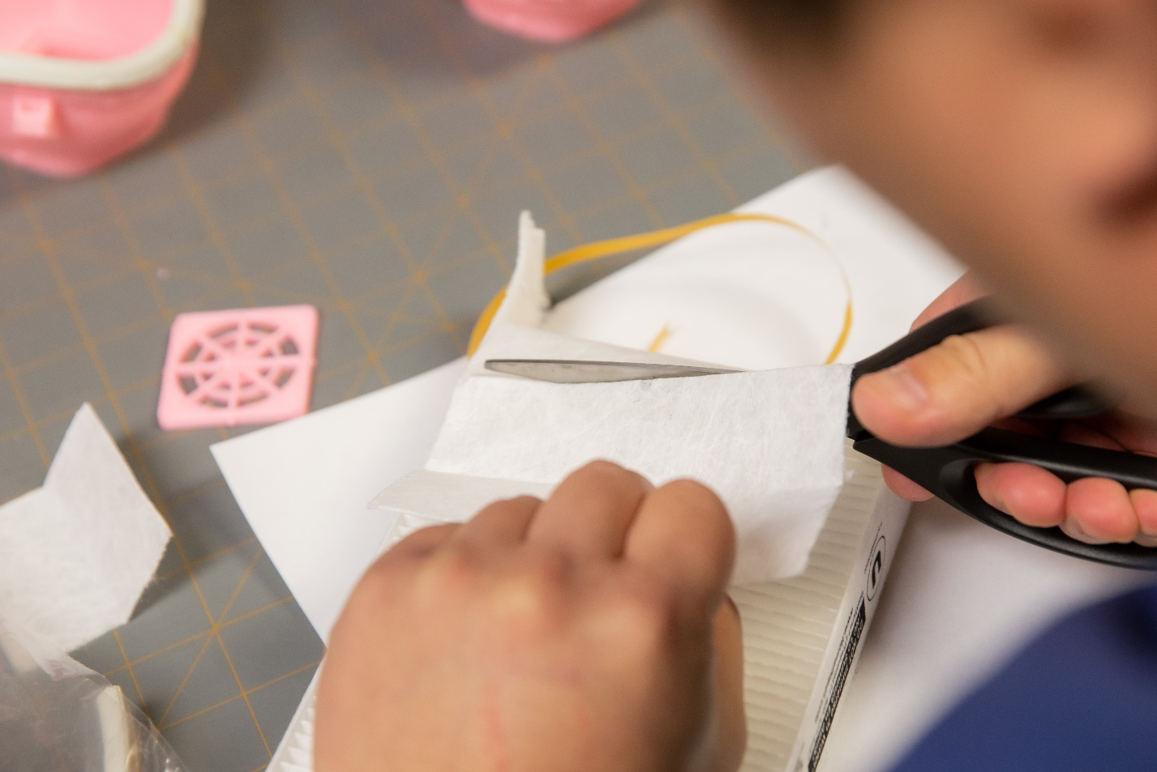

Fold cut sheet in half and cut. This will leave you 2 squares of filter material.

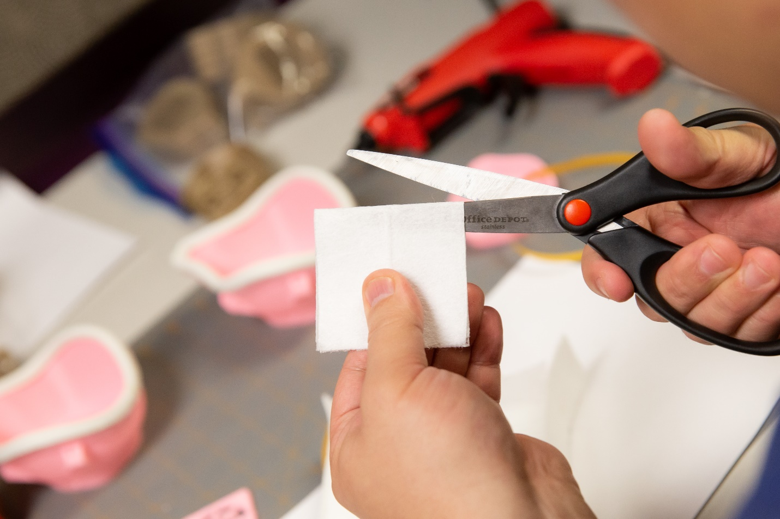

Each square should be enough to cover the Hatch with a generous border around.

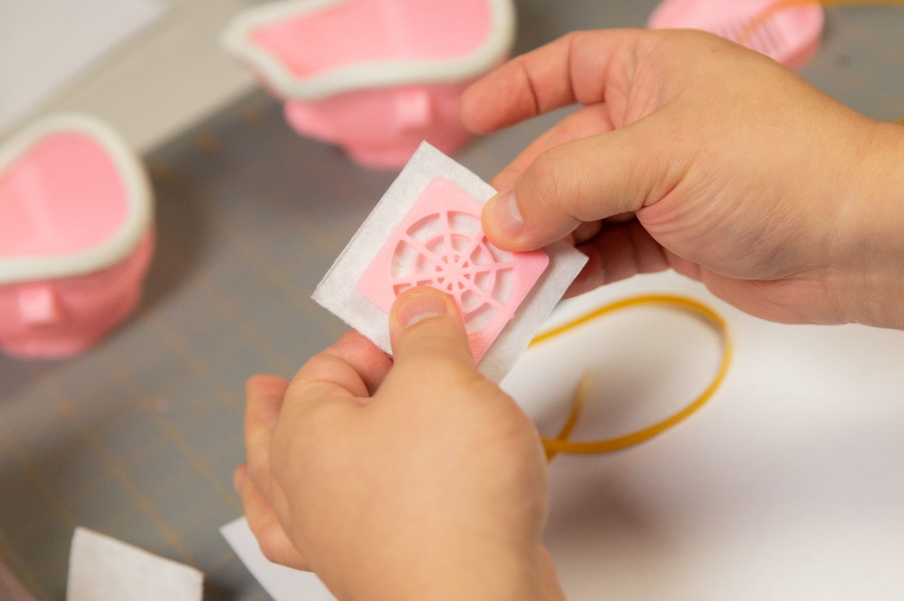

Place filter into the open in the Mask Body. Apply pressure to fit Hatch into opening. The fit is very tight. Consider print multiple Hatches in case one breaks.

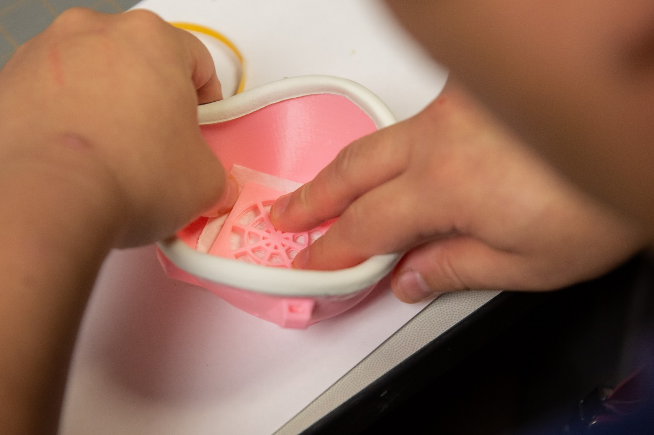

If needed, use a persuader to ensure tight fit. Be careful not to tear the filter or break the Hatch

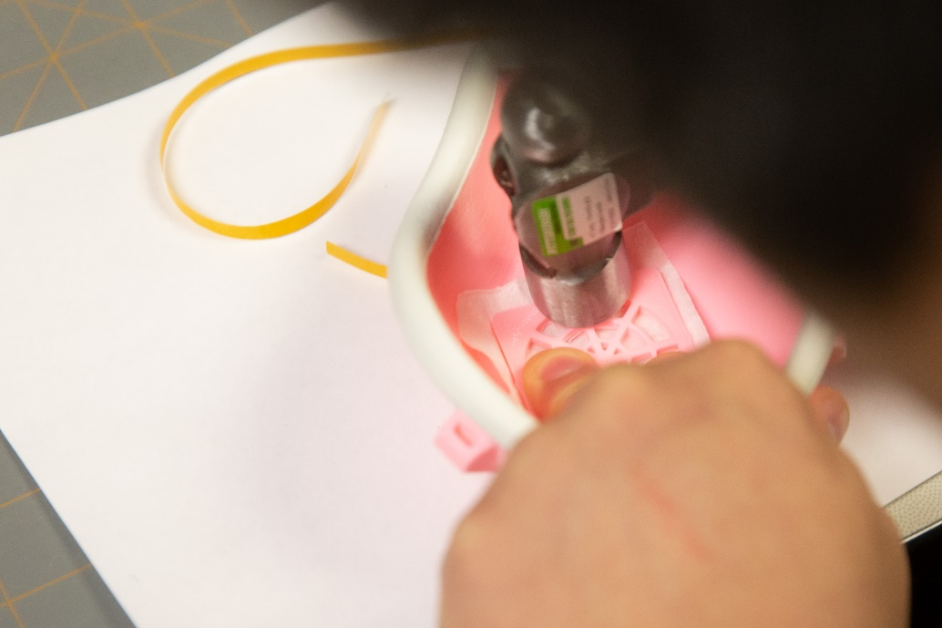

A well seated filter should see the Hatch nearly flush with the Mask Body.

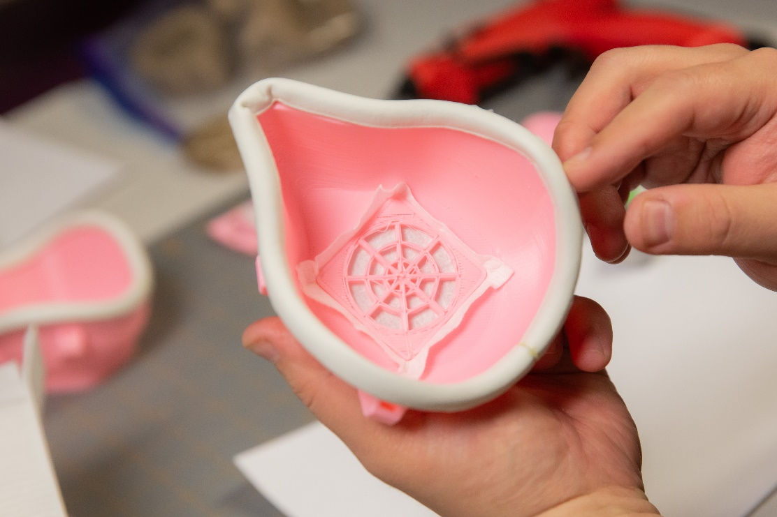

Attach the Nose Cap. It is easiest aligning the bottom first and then working your way up to the top.

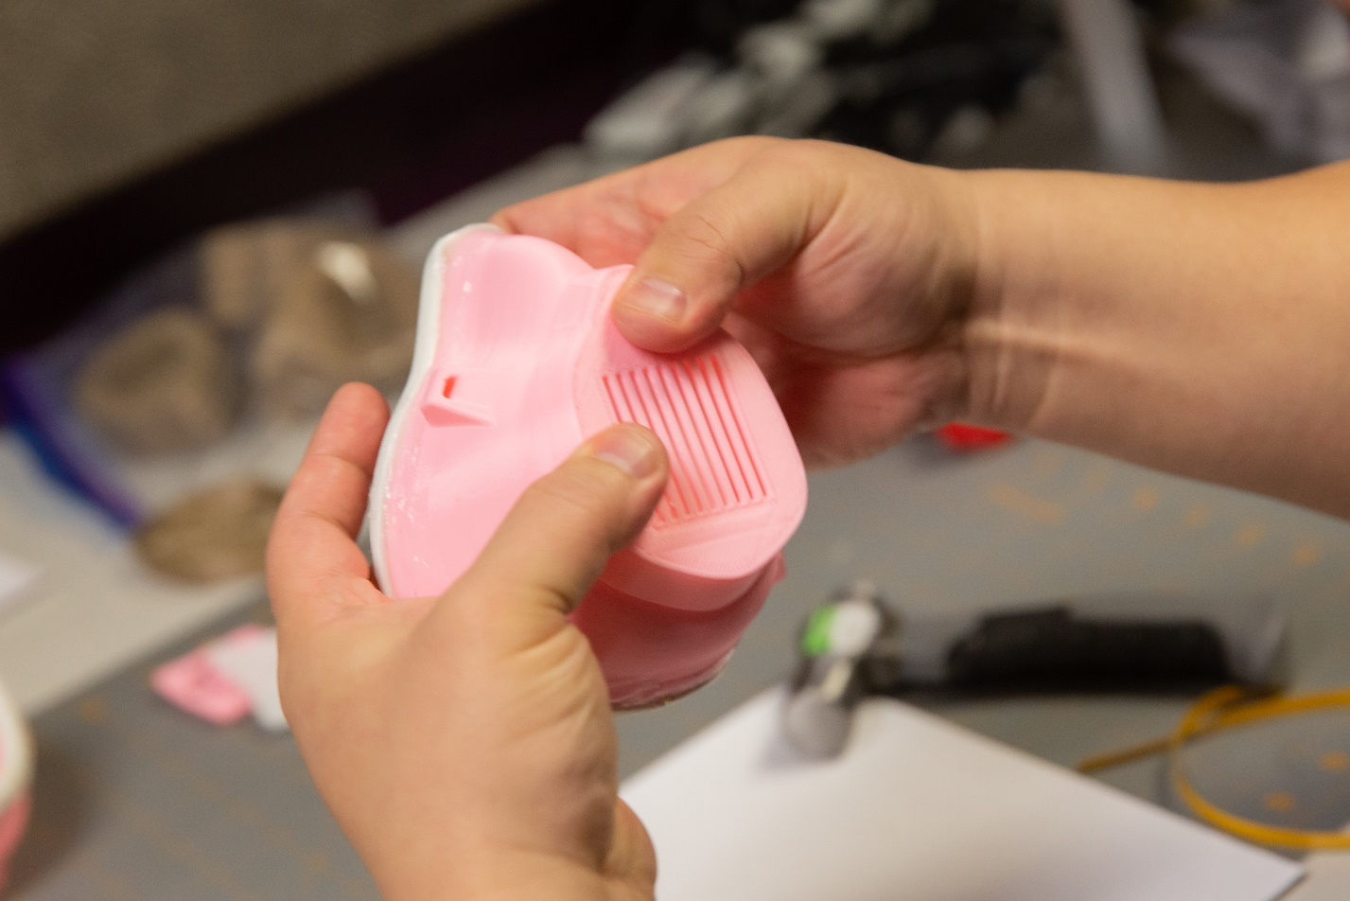

Add ¼ inch elastic or non-latex phlebotomy tourniquets to complete the pseudo N95 mask.

